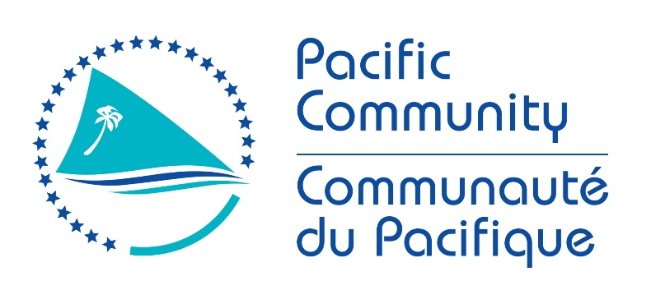

JOB DESCRIPTION
Job Reference:
Job title: | PROTEGE Project Manager
Section: | Climate Change and Environmental Sustainability programme
Line manager: | CCES Director
Junior staff: | 9 persons to recruit: Three regional thematic coordinators, three territorial coordinators, one assistant, one communication officer and one managing/financial controller + a thematic coordinator recruited by SPREP
Job title: | The project Manager is responsible for the proper conduct of the project as a whole. He/she is accountable to SPC, the project partners and the donor. In order to do this, he will have to work closely with the partner territories, SPC and regional organisations such as SPREP, the co delegation agency for this project. His/her action will focus on four main areas of intervention: development and management of the project, advice and strategic support to the territories and partners involved in the project, communication on project results and capitalisation of achievements, and the establishment and maintenance of strong relations with various stakeholders and attention to the sustainability of the results.
Date: | August 2018

Context of the project:

PROTEGE is an integrated project aimed at reducing the vulnerability of human and natural systems to the impacts of climate change by increasing adaptability and resilience. It also targets activities for the sustainable management, conservation and use of biological diversity and its components including water resources. It is financed by the 11th European Development Fund (EDF) in the territories of French Polynesia, New Caledonia, Wallis & Futuna and Pitcairn over a period of 4 years.
The overall objective of the project is to build a sustainable and resilient development of the Overseas Countries and Territories (OCTs) in the face of climate change by relying on biodiversity and renewable natural resources.
The first specific objective aims at enhancing sustainability, adaptation to climate change and the autonomy of the main sectors of the primary sector. It is divided into two expected results:
- Expected Result 1: Bring about an agro-ecological transition for agriculture, predominantly organic, adapted to climate change and respectful of biodiversity; and forest resources are managed in an integrated and sustainable manner;
- Expected Result 2: The reef resources and aquaculture resources are managed sustainably, integrated and adapted to island economies and climate change.
The second specific objective aims at enhancing the security of ecosystem services by preserving water resources and biodiversity. It is broken down into 2 expected results:
- Expected Result 3: Water is managed in an integrated way and adapted to climate change
- Expected Result 4: Invasive alien species are managed to enhance the protection, resilience and restoration of ecosystem services and biodiversity.
This project has an overall budget of EUR 36 million for the period 2018-2022, of which EUR 30.5 million implemented by the Pacific Community (SPC) as the main organisation for implementation and coordination, and EUR 5.5 million by the Secretariat of the Pacific Regional Environment Programme (SPREP), co-delegatee for this project.

Organization Chart

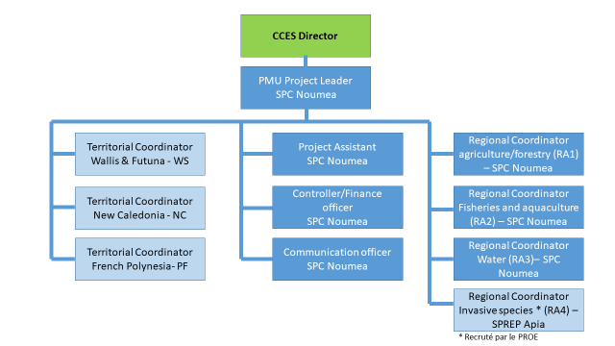

Main areas of intervention:

The position of project Manager mainly covers the following functions or areas of intervention:

1 Preparation and management of the project as a whole
2 Advice and strategic support
3 Communication on project and capitalisation
4 Establishment and maintenance of strong relations with various stakeholders, and sustainability

A general description of the skills required in the above fields of assistance is given below.

Jobholder is accountable for | Jobholder is successful when
1 Project preparation and management, in collaboration with the territories and the project technical team
- Supervise the preparation of the (annual and multiannual) work plans, logframes, project monitoring and evaluation processes and any other strategic plans related to the project implementation and in line with the project objectives;  - Identify the partners competent to implement the project;  - Coordinate complex multidisciplinary components of the project and supervise the contractors responsible for implementing activities;  - Supervise the budgetary and accounting management of the project in line with the requirements of SPC and of the European Union.  - Monitor the implementation of the plans, activities and budgets of the project contractors and partners in line with the requirements of SPC and the donor;  - Recruit specialist consultants;  - Prepare the Regional Steering Committee and provide its secretariat;  - Elaborate technical and financial reports on time, and provide the steering committee with progress reports;  - Organise a mid-term evaluation and a final evaluation of the project to ensure effective monitoring and evaluation of activities and results;  - Supervise the procurement processes and develop the contractual documents necessary for the implementation of the project  - Organise payments, in accordance with the contracts and in accordance with the procedures of SPC and of the European Union. | - Work and implementation plans are prepared and adopted;  - The competent partners are identified on the basis of consultative and participatory processes and involved in implementing the activities.  - The project components are coordinated and implemented as efficiently as possible.  - An annual work plan is drawn up with objectives in line with the overall objective of the project.  - Monitoring is put in place on a technical and budgetary level in line with the requirements of SPC and the donor.  - Specialist consultants are recruited, as appropriate.  - The secretariat and the preparation of the Steering Committee are ensured.  - The technical and financial reports are elaborated and delivered to the Steering Committee in due course.  - The mid-term and final evaluation is carried out.  - The necessary contractual documents are drawn up and signed.  - Payments are made in accordance with procedures
2 Advice and strategic support
- Provide strategic expertise, in particular to ensure the integration of the different components of the project, the synergy between components and the integration both in between the OCTs and within the Pacific region as a whole;  - Finalise the definitions of the components’ activities and their indicators, the elaboration of the related action plans on the basis of the criteria defined by the project, in collaboration with the territories and stakeholders, and the technical project team;  - Gain support of the project partners;  - Ensure the dissemination and ownership of concepts and approaches developed within the project in the different technical units of SPC, territorial institutions, regional organisations and other partners;  - Promote a participatory approach in collaboration with the different stakeholders;  - Make concrete proposals adapted to local contexts and analyse the different information to identify the best models to be adopted;  - Promote a learning approach that draws upon the lessons learned in previous projects (notably INTEGRE), in particular in terms of implementation arrangements and results achieved.  - Ensure that the policies of SPC are taken into account, in particular as regards gender and equity, social and environmental responsibility, human rights and the protection of children. And ensure the implementation of the social and environmental responsibility component of the project (in conjunction with the SPC Environmental Sustainability Coordinator). | - The different components of the project work in synergy and the project is fully integrated in the regional efforts of OCTs and of the Pacific region;  - The action plans are finalised and implemented;  - A participatory approach is established;  - Concrete proposals adapted to local contexts are formulated;  - The incorporation of gender and equity, social and environmental responsibility and human rights is documented.
3 Communication on the project and capitalisation of the results and lessons learned
- Supervise the design and finalisation of the communication plan, as well as the communication activities and evaluate the results;  - Use the media to publicise the project and promote the results, in collaboration with the communication services of SPC, SPREP and the territories and partners concerned;  - Participate in regional and international conferences and workshops; and advocate to political and administrative decision makers for the project approaches and outcomes.  - Ensure the capitalisation of the project by documenting the results and lessons learned. | - A communication plan is drawn up;  - Appropriate communication tools are developed in synergy with the territories, as well as with the communication services of SPC and SPREP;  - External partners take over and appropriate the concepts developed by the project;  - Capitalisation documents and tools are developed throughout the life of the project and shared.
4 Establishment and maintenance of strong relations with various stakeholders and sustainability
- Develop and maintain close working relations with SPC officers, institutional and technical partners of the project in the four territories concerned, regional organisations, donors and the main institutions involved, including research organisations and civil society.  - Participate in actions carried out in collaboration with other organisations.  - Contribute to the strengthening of institutional and technical links between the OCTs and the Pacific island countries and territories and thus contribute to the sustainability of the action.  - Participate in the strengthening of the project partners’ capacity and knowledge;  - Ensure vigilance on the factors of sustainability of the project results. | - SPC divisions and other regional organisations are strongly involved and actively participate in the project.  - The project actors are involved in activities carried out by other organisations on these themes.  - The OCTs have reached partnership agreements with other Pacific states.  - The project partners have acquired the skills and knowledge to contribute to the sustainability of the project results.

Comment

The results specified above are merely indicative.

Complexity of the work:

Most difficult tasks:
- Coordinate a high number of actions with many partners
- Ensure that the various partners are regularly involved
- Ensure acceptance and favour ownership of the approaches and concepts promoted by the project by the various partners
- Enable joint work between OCTs and other Pacific states and territoires, in particular relying on SPC and SPREP networks
- Ensure full compliance of administrative procedures and processes with EU and SPC requirements.
K

Functional Relationships

Main internal and external contacts | Typical contact type
- External —  - National and provincial administrations  - Official SPC contact points in the countries  - Territorial Authorising Officers  - Non-governmental organisations  - Regional organisations  - Donors and funding partners  - Consultants and contractors | - participation in meetings and seminars  - daily collaboration by e-mail, telephone, etc.  - technical support  - sharing of information
- Internal  - Coordinators and teams of the RESCCUE, PEUMP and other projects of interest for PROTEGE  - SPC Divisions (LRD, FAME, GEM in particular)  - Communication unit, procurement department, finance department, travel unit  - SPC in general | - participation in meetings and seminars  - daily collaboration by e-mail, telephone, etc.  - technical support  - sharing of information

Level of delegation:

The consultant shall:

- manage operating budgets totalling 6 900 000 € [and a development budget of 35 200 000 €] over four years.
- is empowered to authorise payments of up to maximum amounts of 50.000 € in line with the policy of delegation of SPC
- is authorised to sign ordinary letters and to communicate with the territories and stakeholders
- is authorized to spend € 2,000 in connection with the SPC delegation policy

Personal profile:

This section is designed to capture the expertise required for the role at the 100% fully effective level. (This does not necessarily reflect what the current position holder has.) This may be a combination of knowledge / experience, qualifications or equivalent level of learning through experience or key skills, attributes or job specific competencies.

Qualifications

Very important: | Desirable:
A post-graduate degree in economics of the environment, programme management or equivalent | A Master’s degree in project management and monitoring, a PhD or equivalent

Knowledge/experience
Essential: | Desirable:
- 10 years’ significant experience, including at least five years in international project management.  - Proven experience in the management of integrated and multi-sector projects funded by the European Union  - Strategic understanding of sustainable development issues in Oceania and in particular in the Overseas Territories  - Ability to influence and guide others  - Proven capacity to manage a dispersed project team  - Be able to drive new approaches and devise innovative solutions  - Be a good communicator and able to navigate well in a political environment  - Speak and write French fluently and have a very good command of English. | - Experience of working with the Pacific Overseas Territories  - Experience of multicultural work  - Being used to distant and long professional journeys

Key Skills/Attributes/Job Specific Competencies

The following levels would typically be expected for the 100% fully effective level:

Expert | - Management of projects financed by the European Union  - Leadership and team management  - Good communicator, able to navigate in a political environment
Advanced | - Strategic and innovative thinkingh  - High proficiency in writing and in drawing up executive summaries  - Budget management  - Good command of English
Working Knowledge | - Knowing how to manage a project with a multilingual and multi-country approach  - Relations with donors  - Project monitoring & evaluation tools  - Suitable communication tools  - Knowledge of the networks and institutions related to the project (agriculture, fisheries and aquaculture, water, invasive species)
Awareness | - Knowledge of global development challenges, in particular in terms of climate change and biodiversity

Key Behaviours

All employees are measured against the following Key Behaviours as part of Performance Development:
- Commitment/ Accountability
- Change and innovation
- Effective Communications & Relationships
- Working with others
- Promoting equity and equality
- Strategic judgment
- Capacity building of individual team members
- Leadership

Personal Attributes

- Strong commitment
- High level of professional integrity and ethics
- Open-minded and friendly demeanor
- Knowing how to identify the difficulties and resolve them
- Knowing how to plan multiple activities while respecting deadlines

Changes to the job description:

From time to time it may be necessary to consider changes in the job description in response to the changing nature of the work environment - including technological requirements or statutory changes. Such change may be initiated as necessary by SPC. This Job Description may also be reviewed as part of the preparation for performance planning for the annual performance cycle.

Approved:

Manager/Supervisor Date

Employee Date

Head of Division Date

